Project Report: Customer Shopping Behavior Analysis & Interactive Dashboard

1. Project Overview
This project focuses on executing an end-to-end data analytics workflow on customer shopping behavior datasets. Utilizing Python for initial preprocessing, PostgreSQL for structured relational data querying, and Power BI for user-facing interactive reporting, the project evaluates 3,900 transactional records across multiple retail domains. The foundational objective is to discover underlying spending trends, define precise customer segment distributions, analyze product review balances, and evaluate shipping configurations to supply data-driven strategic initiatives.
2. Dataset Summary
- Total Records: 3,900 rows
- Data Attributes: 18 distinct features
- Core Feature Profiles:
  - Demographics: Age, Gender, Location, Subscription Status.
  - Purchase Variables: Item Purchased, Category, Purchase Amount, Season, Size, Color.
  - Behavioral Indicators: Discount Applied, Promo Code Used, Previous Purchases, Purchase Frequency, Review Rating, Shipping Type.
- Data Integrity Profile: Encountered 37 missing observations isolated exclusively within the Review Rating attribute.

3. Data Extraction & Preprocessing (Python Pipeline)
The initial stage focused on programmatic data parsing, structural standardization, quality engineering, and database ingestion using Python:
- Initialization & Profiling: Loaded raw records via Pandas, evaluating structural types with .info() and distributional bounds with .describe().
- Null Value Imputation: Addressed data gaps by calculating the median review rating per product category and programmatically mapping those values into the missing fields.
- Attribute Standardization: Converted all raw text column spaces into standard snake_case formats to remove execution friction in PostgreSQL.
- Feature Engineering:
  - Constructed an age_group attribute by splitting ages into four equal-frequency quantile groupings (pd.qcut).
  - Created purchase_frequency_days by translating textual purchase descriptions into clear numerical interval indicators.
- Redundancy Resolution: Checked for duplicate patterns between promotional features; verified that promo_code_used perfectly tracked discount_applied, allowing it to be safely dropped.
- Database Integration: Initialized an active database link through SQLAlchemy and psycopg2-binary, executing an automated table export straight into PostgreSQL.
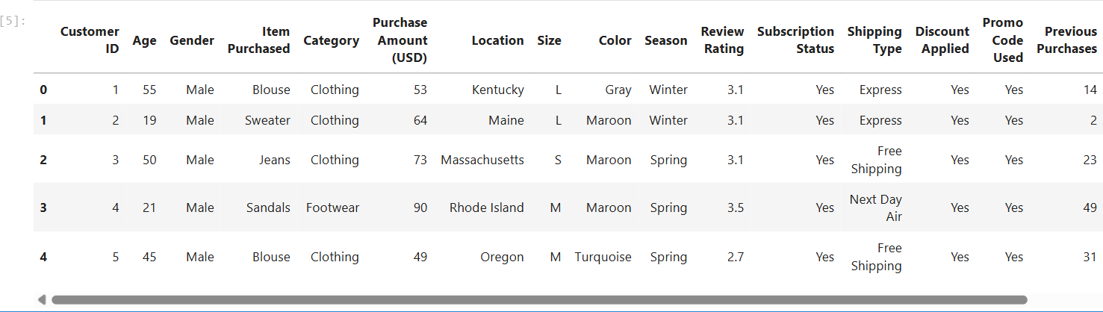
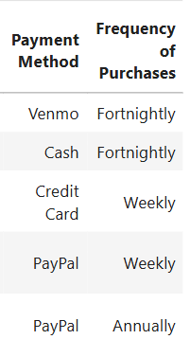
4. Data Analysis & Query Outputs (PostgreSQL Verification)
With the dataset successfully migrated into PostgreSQL, targeted database queries were executed to verify core business metrics.
- 4.1. Revenue Distribution by Customer Gender
  - Analysis Focus: Evaluating total revenue weight between male and female customer segments.
  - 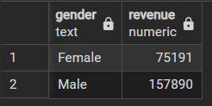
- 4.2. High-Spending Discount Users Analysis
  - Analysis Focus: Identifying value shoppers who used active discounts but still maintained transactional values above the dataset average.
  - 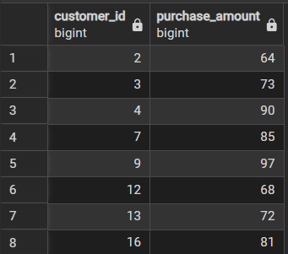
  - 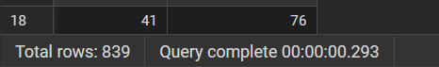
- 4.3. Top Product Profiles by Customer Satisfaction Rating
  - Analysis Focus: Finding the top 5 inventory items carrying the highest overall average review ratings.
  - 📸 [INSERT SCREENSHOT HERE]: Paste the pgAdmin data output view showing the top 5 highest-rated products.
  - 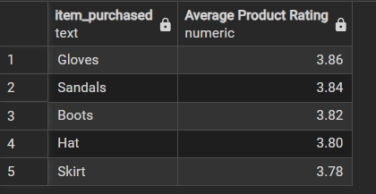
- 4.4. Logistical Shipping Mode Cost Matrix Comparison
  - Analysis Focus: Comparing average customer purchase tickets between Standard and Express logistical options.
  - 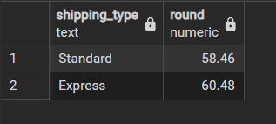
- 4.5. Subscription Tier Revenue Performance Profiling
  - Analysis Focus: Comparing total volume counts, individual average spend, and grand total revenues between subscribers and non-subscribers.
  - 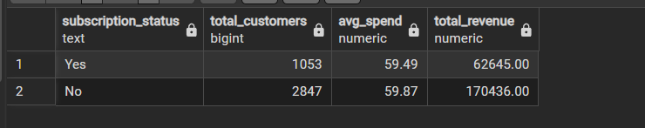
- 4.6. Top 5 Discount-Dependent Inventory Items
  - Analysis Focus: Tracking which product categories rely most heavily on active discount promotions to secure conversions.
  - 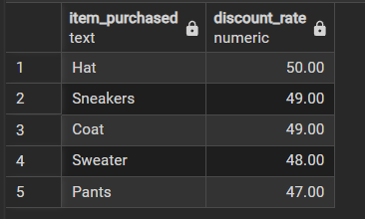
- 4.7. Customer Loyalty Behavioral Segmentation
  - Analysis Focus: Grouping the client population into New, Returning, and Loyal buckets based on historical transaction volumes.
  - 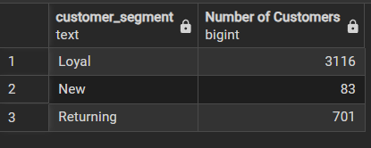
- 4.8. Category Inventory Leaders Matrix
  - Analysis Focus: Isolating the top 3 most popular items across every major category sector based on total order counts.
  - 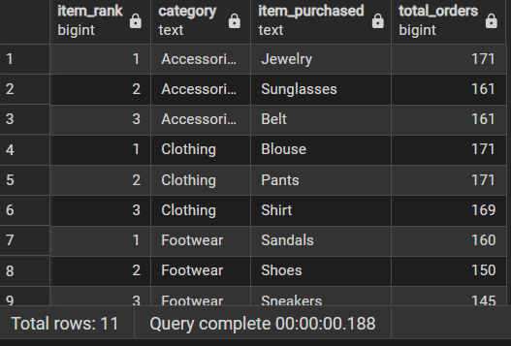
- 4.9. Subscription Propensity Profiles Among Repeat Buyers
  - Analysis Focus: Evaluating whether high-retention buyers (more than 5 historic transactions) display a higher tendency to join the subscription tier.
  - 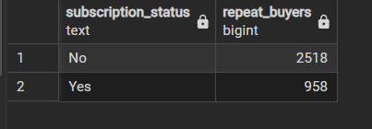
- 4.10. Revenue Contribution Profiles by Analytical Age Brackets
  - Analysis Focus: Tracking total consumer financial injection segments grouped by analytical age groups.
  - 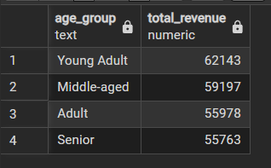

5. Power BI Dashboard
The cleaned customer shopping dataset was visualized using Microsoft Power BI to present key metrics and shopping trends in an interactive dashboard. The dashboard provides an overview of customer purchasing behavior, product category performance, subscription status, and spending patterns across different age groups.
The dashboard includes the following visualizations:
- Key Performance Indicators (KPIs): Displays the total number of customers, average purchase amount, and average review rating.
- Subscription Analysis: Shows the distribution of customers based on their subscription status.
- Category-Wise Analysis: Compares revenue and sales across product categories.
- Age-Group Analysis: Presents revenue and sales across different customer age groups.
- Interactive Slicers: Allows users to filter the dashboard by subscription status, gender, product category, and shipping type.
These visualizations help present the data in an understandable format and make it easier to explore customer behavior and purchasing patterns.
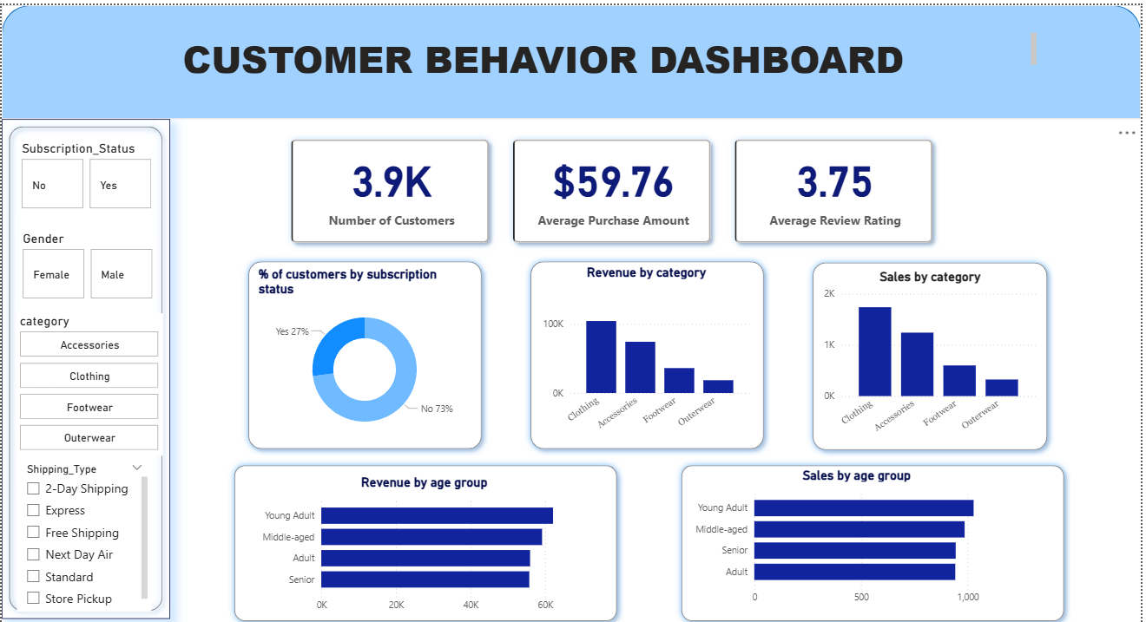

6. Key Findings and Business Recommendations

The analysis of customer shopping behavior can help identify patterns in purchasing activity, product preferences, discount usage, and subscription behavior. The SQL queries and Power BI dashboard are designed to explore these areas and support data-driven business decisions.
Based on the results obtained from the analysis, the following business actions can be considered:
- Increase Subscription Adoption: Evaluate opportunities to encourage more customers to subscribe through relevant benefits and promotional offers.
- Strengthen Customer Loyalty: Consider loyalty rewards and targeted engagement strategies to encourage repeat purchases.
- Improve Discount Planning: Examine discount usage across products to understand where promotions are most frequently applied and assess their business value.
- Promote Popular and Highly Rated Products: Use product purchase counts and review ratings to identify products that may benefit from additional visibility.
- Develop Targeted Marketing Strategies: Use customer age groups, purchasing patterns, and shipping preferences to design more relevant marketing campaigns.
The effectiveness of these recommendations should be evaluated using the actual query results and dashboard metrics before implementation.

